# Internship Project : Heart disease Prediction

**SUBMITTED BY:**

**NAME: KAUSHAL JAIN**

**EMAIL ID:** [**jainkaushal899@gmail.com**](mailto:jainkaushal899@gmail.com)

**BATCH: ML WITH PYTHON**

**CERTIFICATION CODE: TCRIG02R65**

**GROUP: OWN**

**QUESTION:**

Please perform the below steps in a Google Colab or Jupyter Notebook as per your convenience:

I**n this assignment , we need to prediction of Heart disease detection**

**Features:**

This database contains 76 attributes, but all published experiments refer to using a subset of 14 of them. In particular, the Cleveland database is the only one that has been used by ML researchers to

this date. The "goal" field refers to the presence of heart disease in the patient. It is integer valued from 0 (no presence) to 4.

We will create a model with the following steps:

● Import the relevant packages

● Download and explore the dataset

● Prepare the dataset for training

● Use any prediction algorithm based upon the EDA

● Train the model to fit the data

● Make predictions using the trained model

● Create a test case and generate a predicted result from the system

**SOURCE CODE AND OUTPUTS:**

# Importing Required Libraries

import pandas as pd

import numpy as np

import matplotlib.pyplot as plt

import seaborn as sns

from sklearn.model_selection import train_test_split

from sklearn.preprocessing import StandardScaler

import warnings

warnings.filterwarnings('ignore')

#Importing the Dataset

dataset = pd.read_csv(r'C:\Users\jaink\Downloads\heart.csv')

dataset.head()

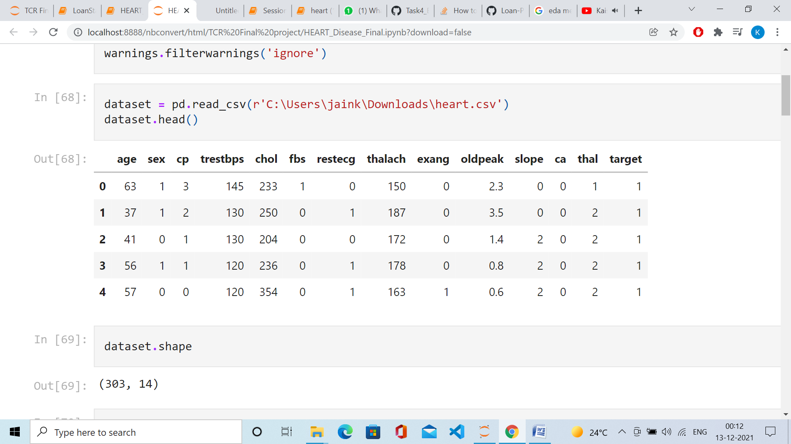

dataset.tail()

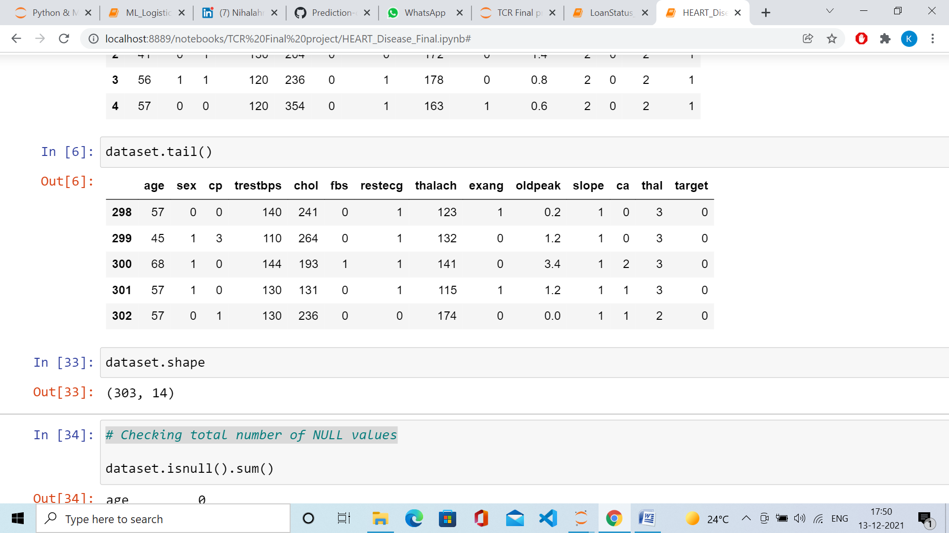

dataset.shape

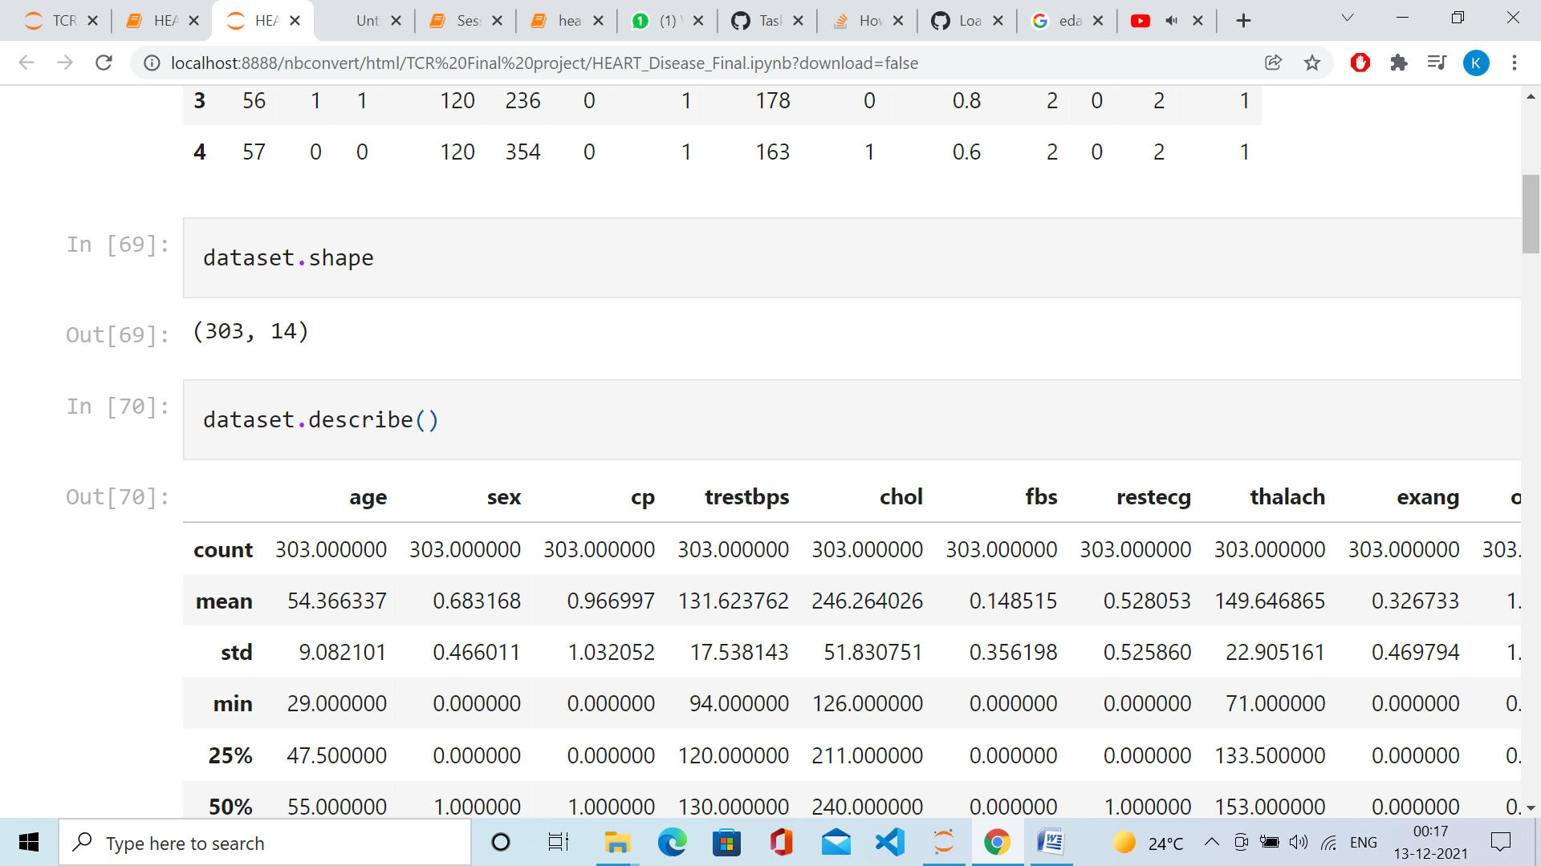

# Checking total number of NULL values

dataset.isnull().sum()

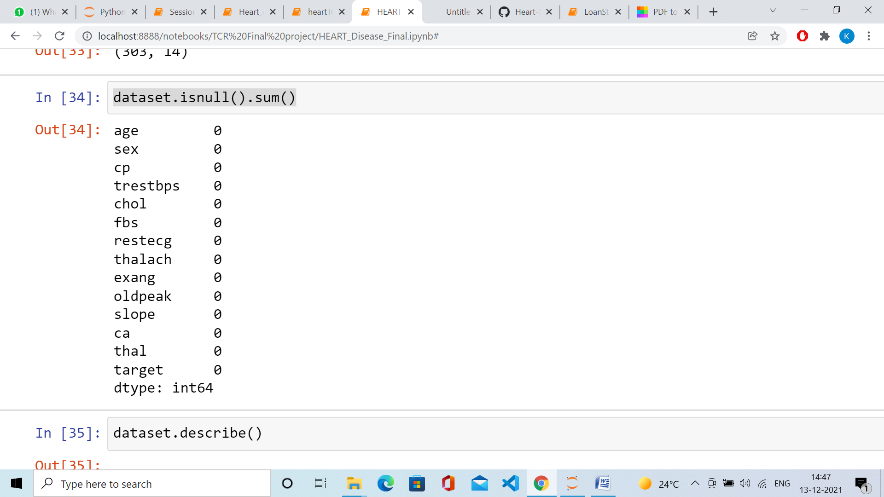

dataset.describe()

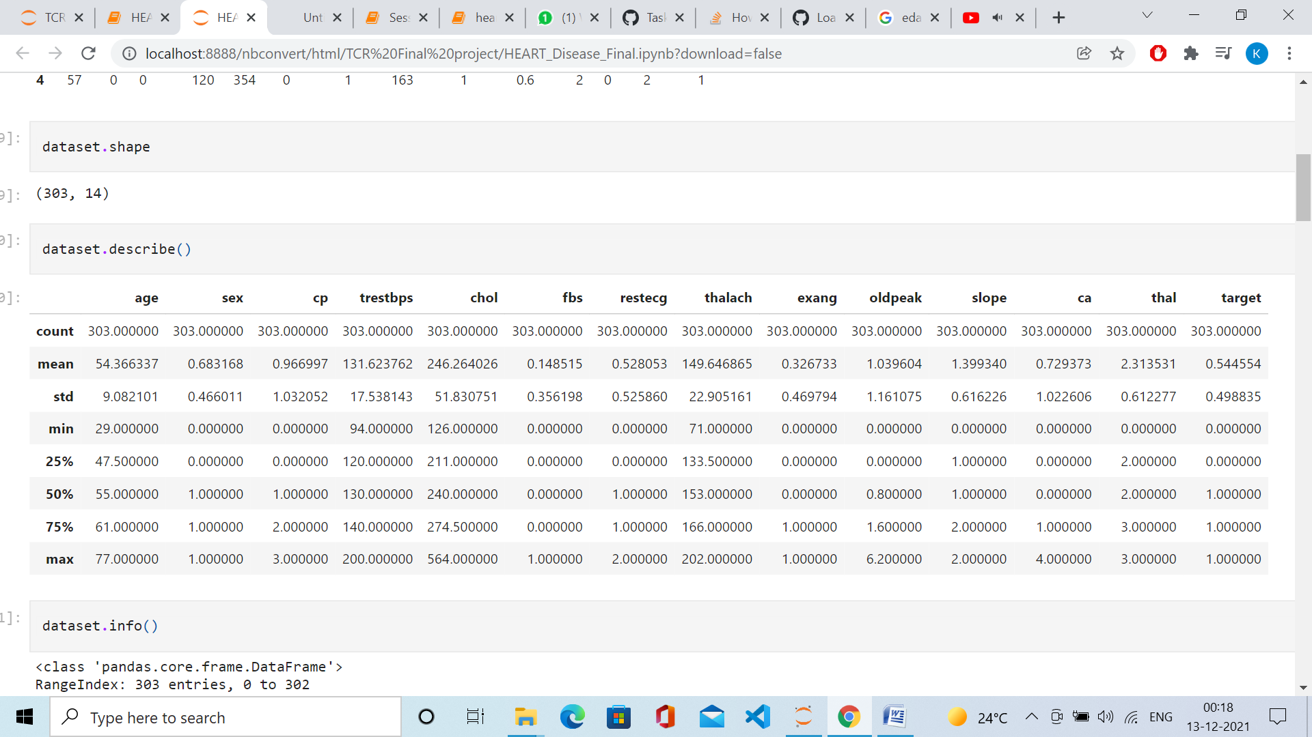

dataset.info()

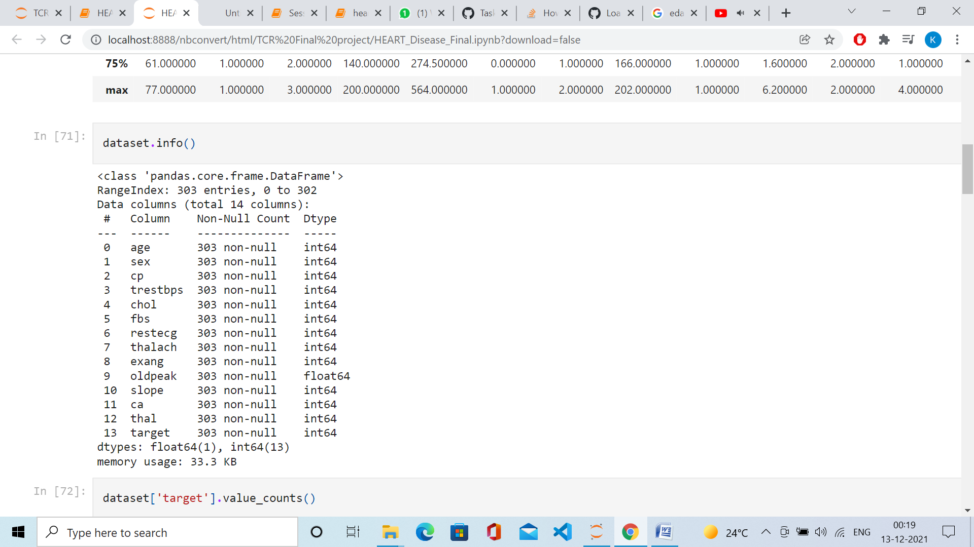

#Exploratory Data Analyis

#Analysing the variables

dataset['target'].value_counts()

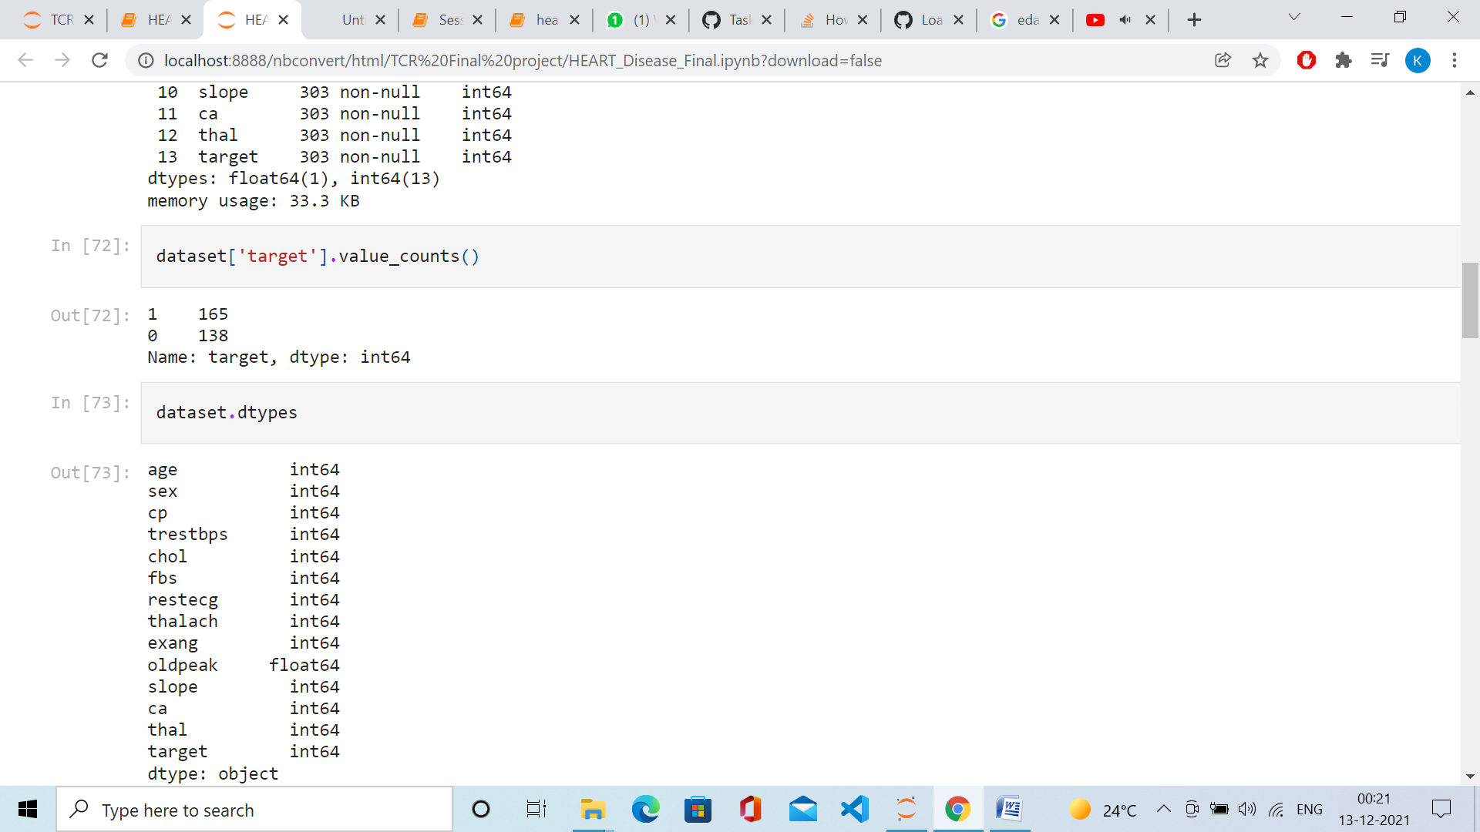

dataset.dtypes

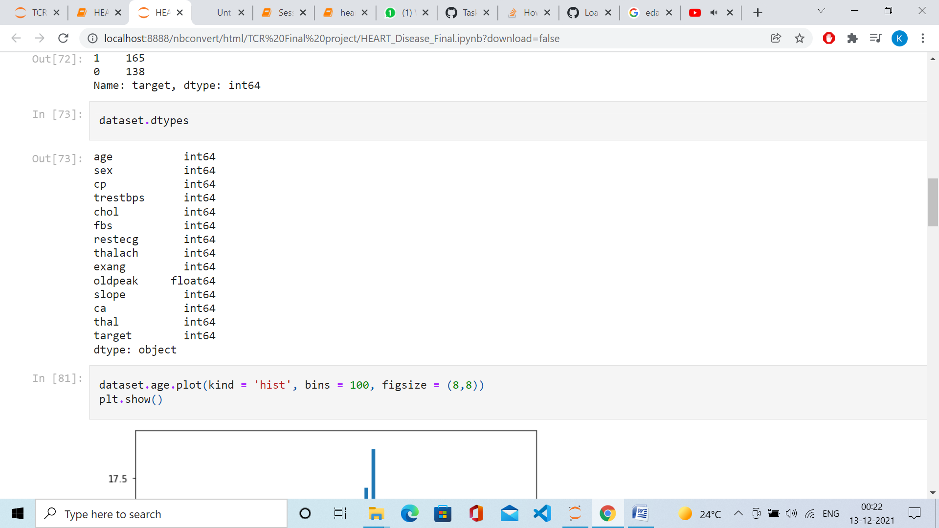

dataset.age.plot(kind = 'hist', bins = 100, figsize = (8,8))

plt.show()

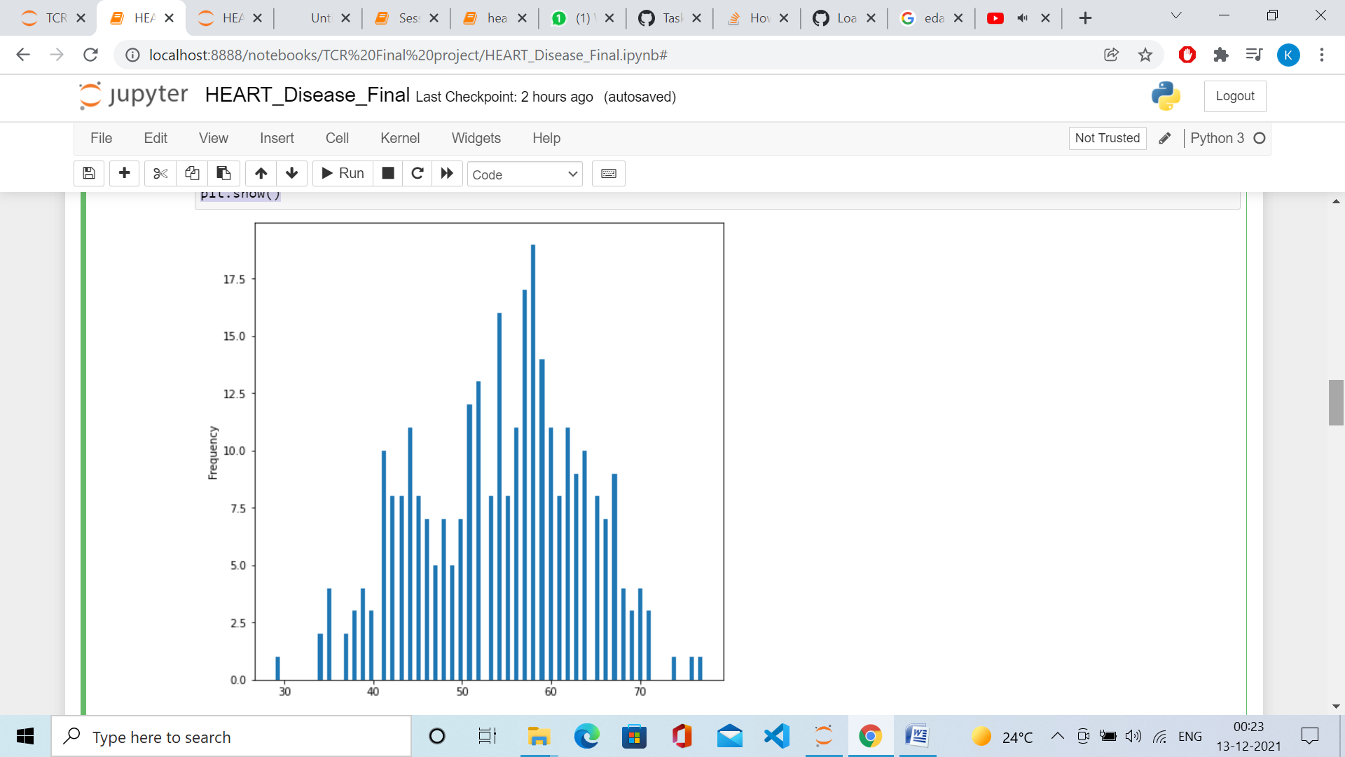

sns.countplot(dataset['target'])

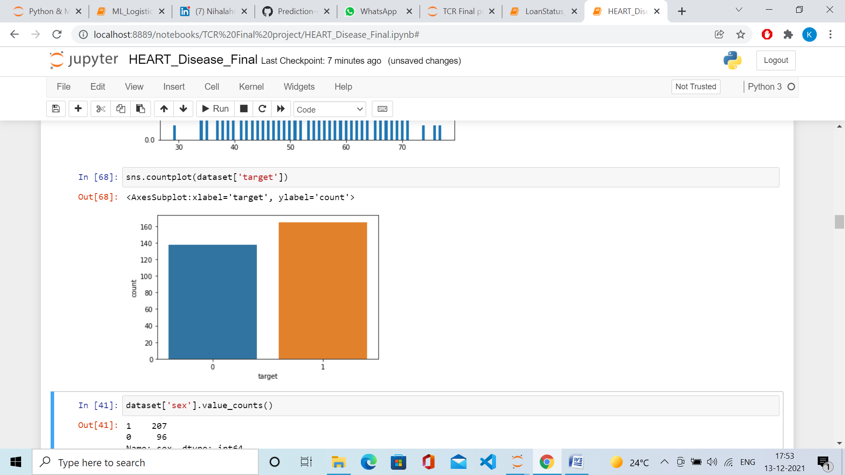

dataset['sex'].value_counts()

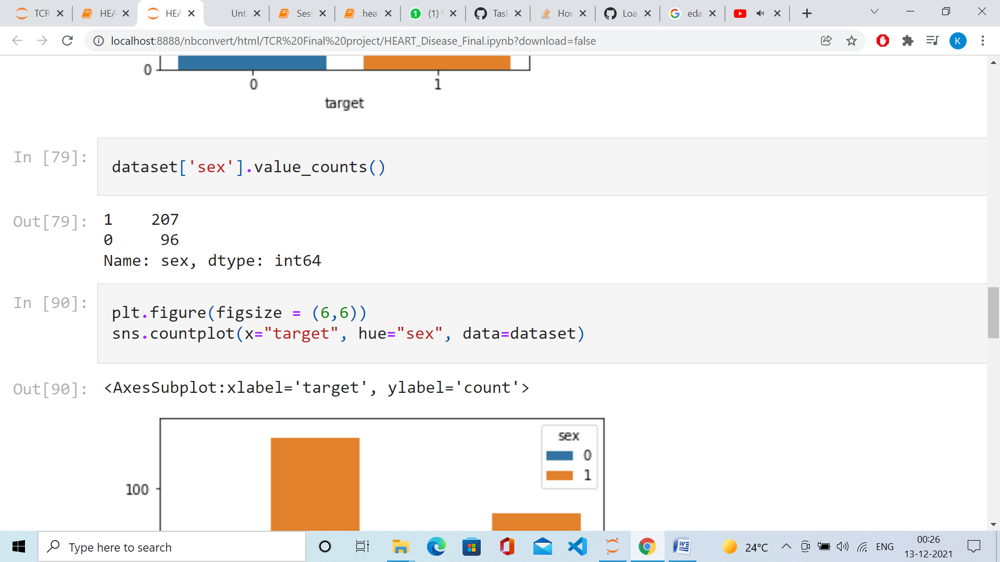

sns.barplot(dataset["sex"],dataset["target"])

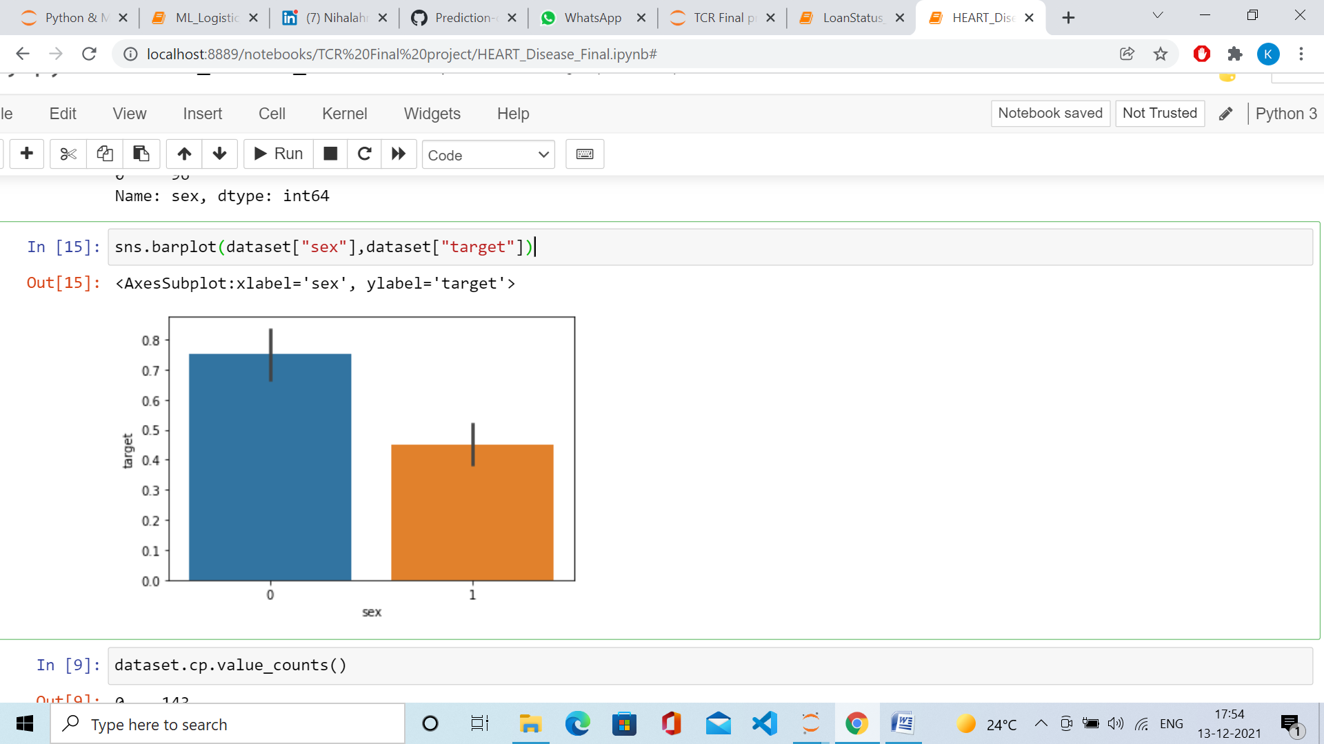

dataset.cp.value_counts()

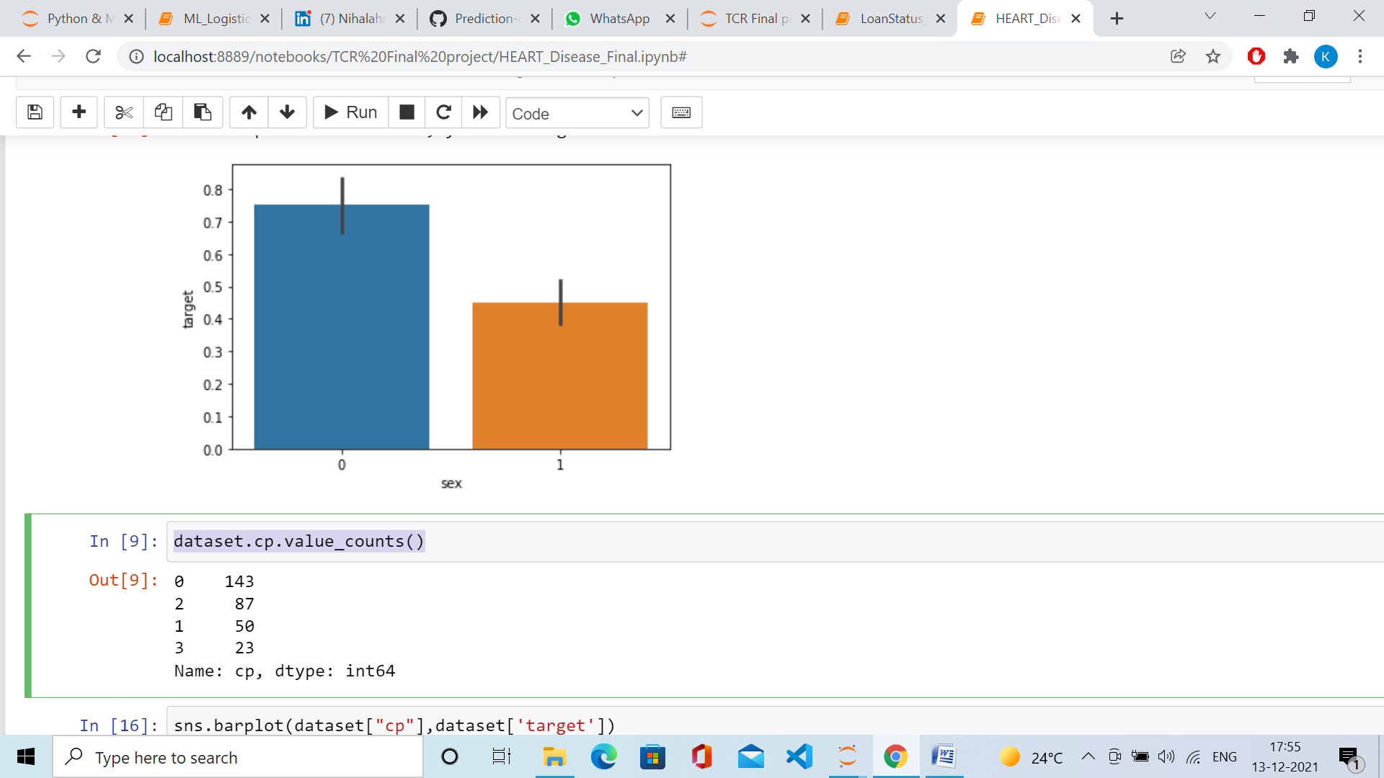

sns.barplot(dataset["cp"],dataset['target'])

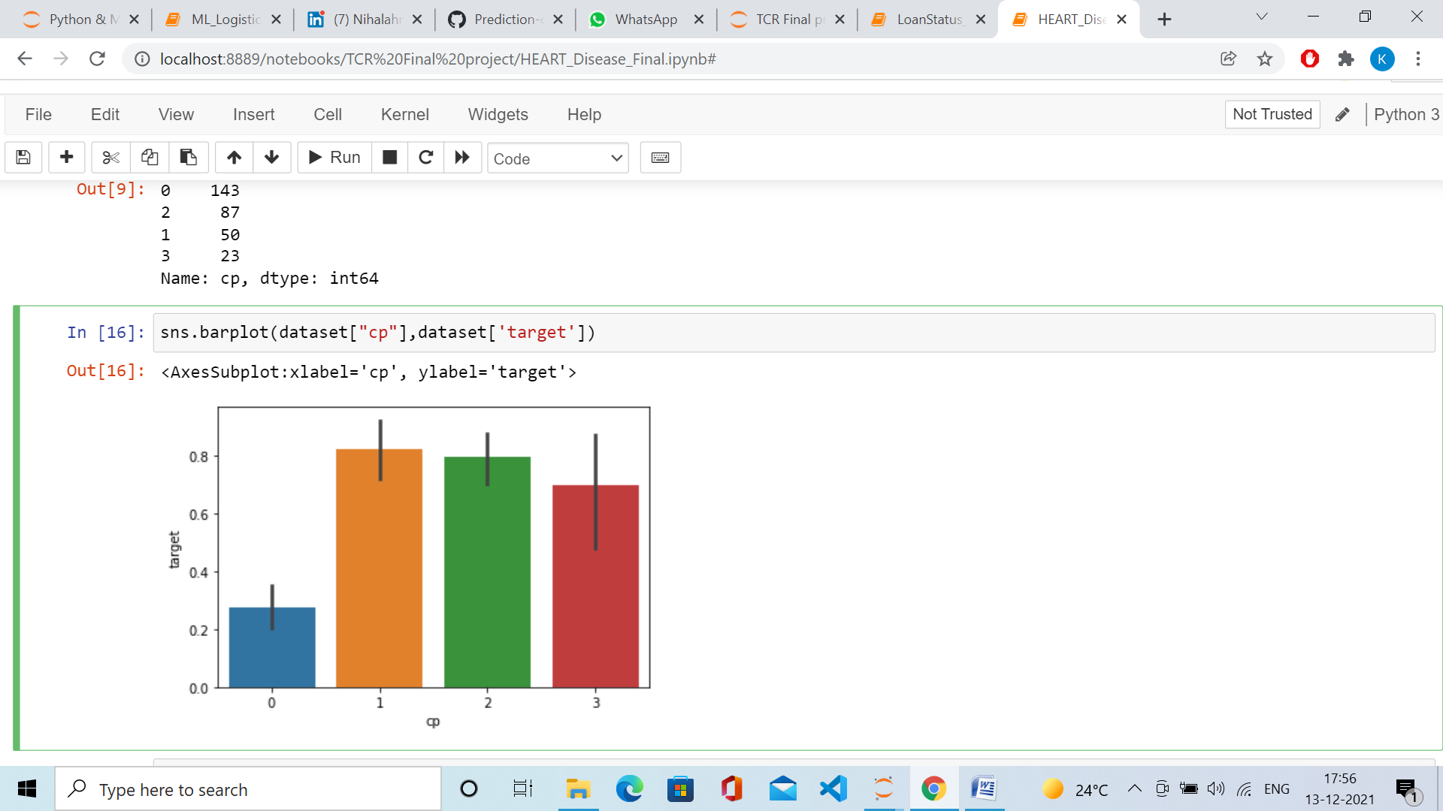

dataset.restecg.value_counts()

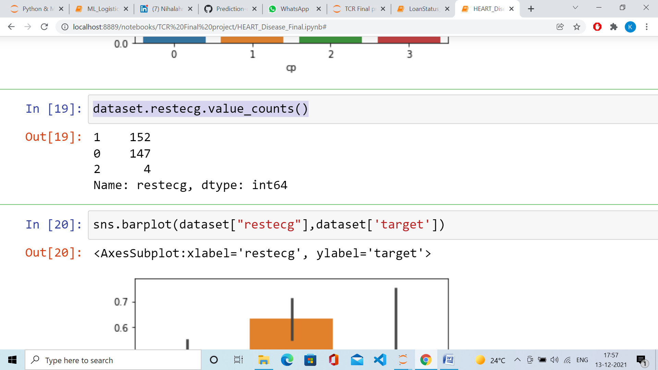

sns.barplot(dataset["restecg"],dataset['target'])

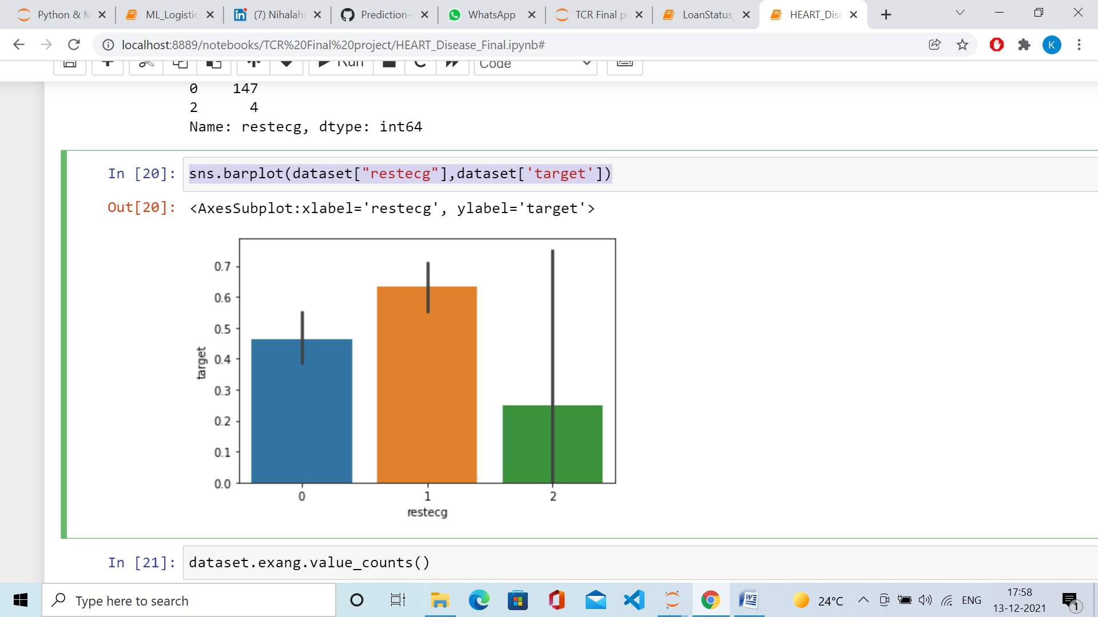

dataset.exang.value_counts()

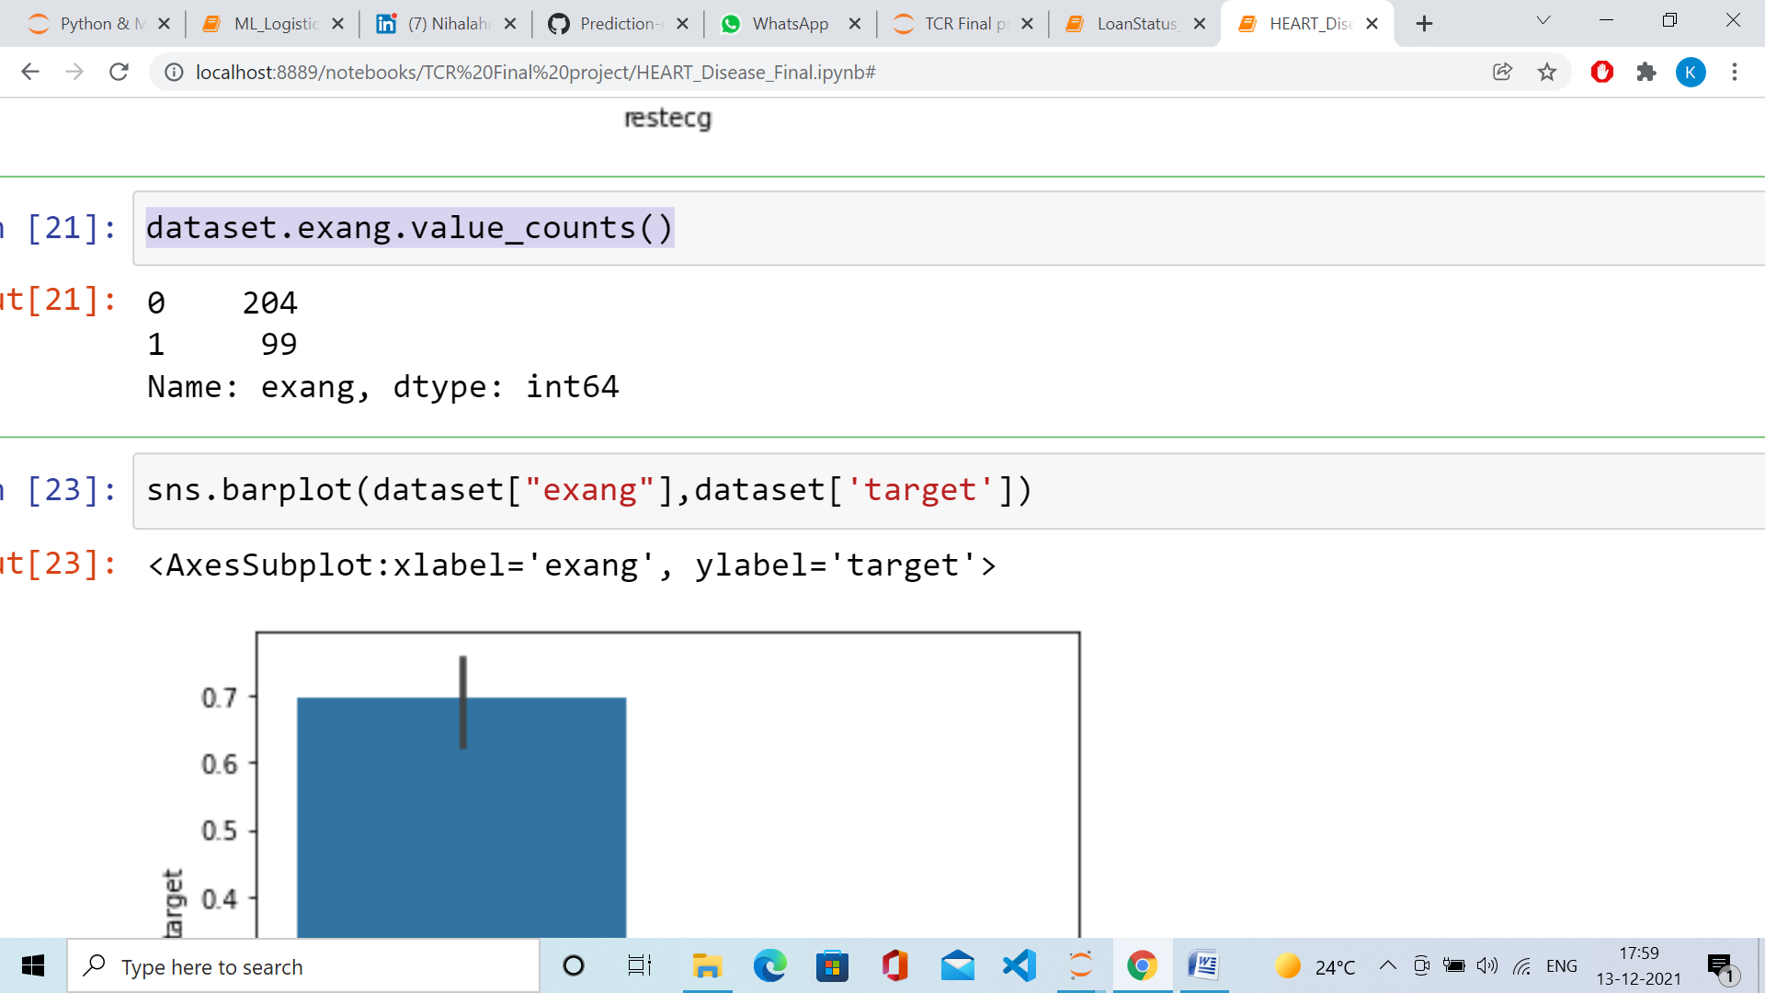

sns.barplot(dataset["exang"],dataset['target'])

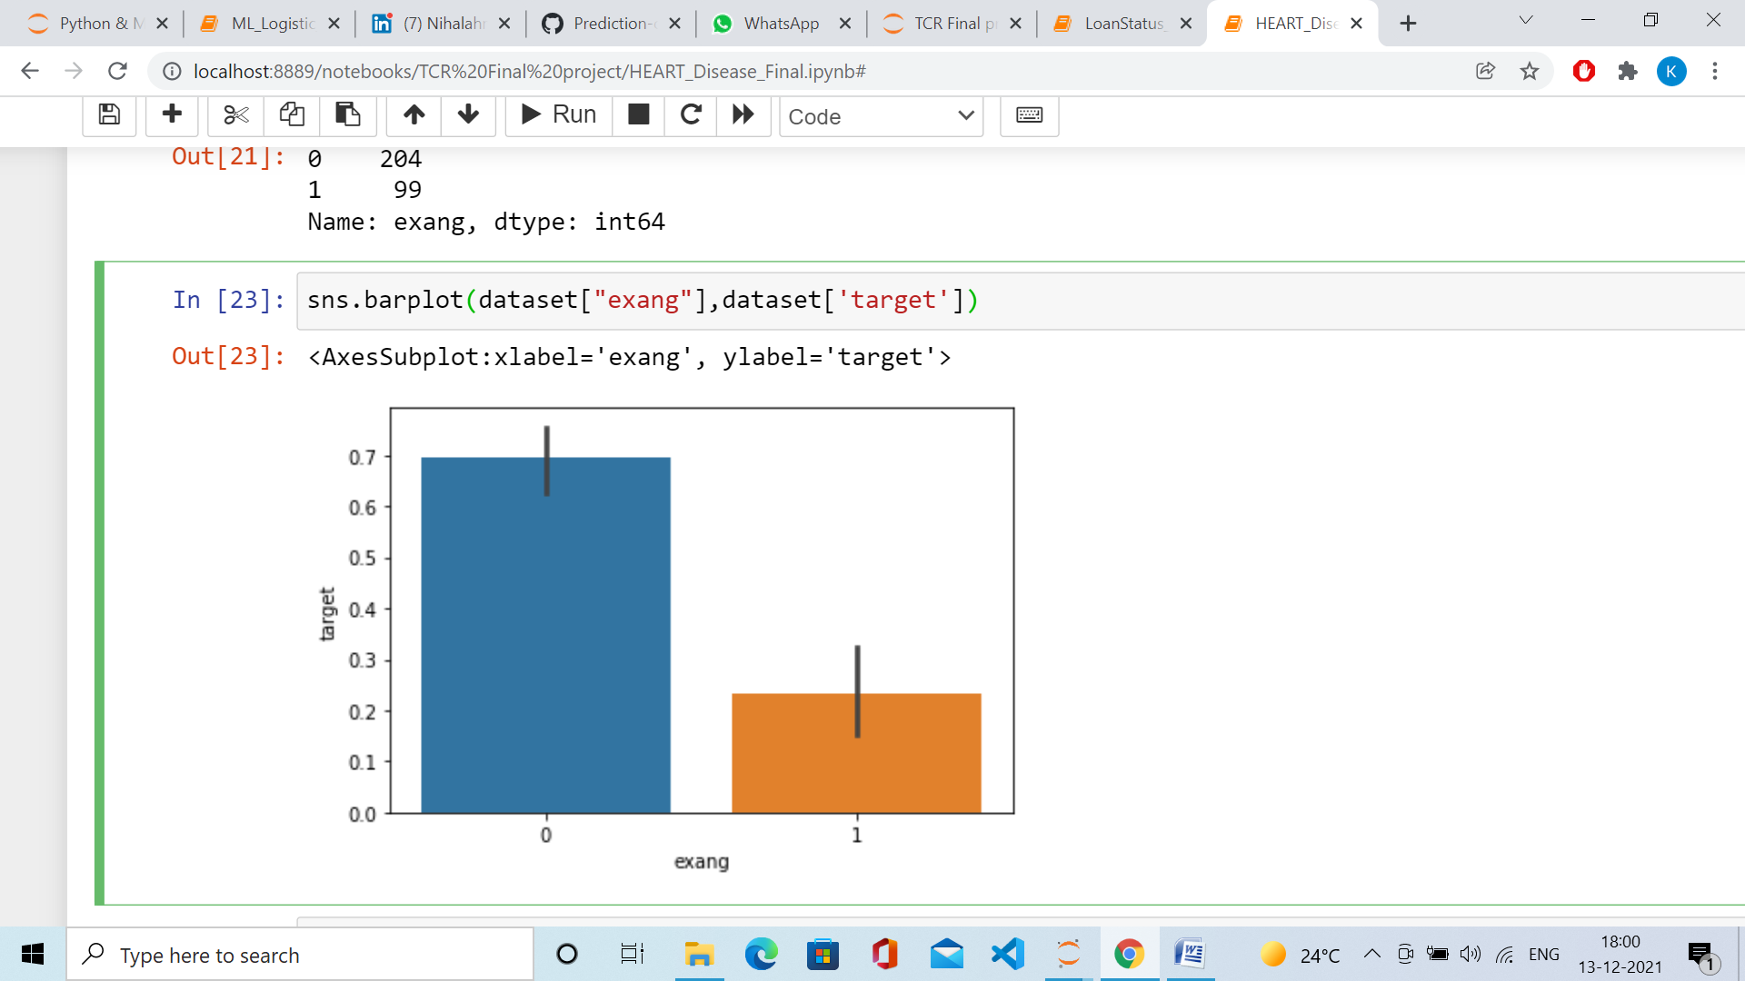

dataset.slope.value_counts()

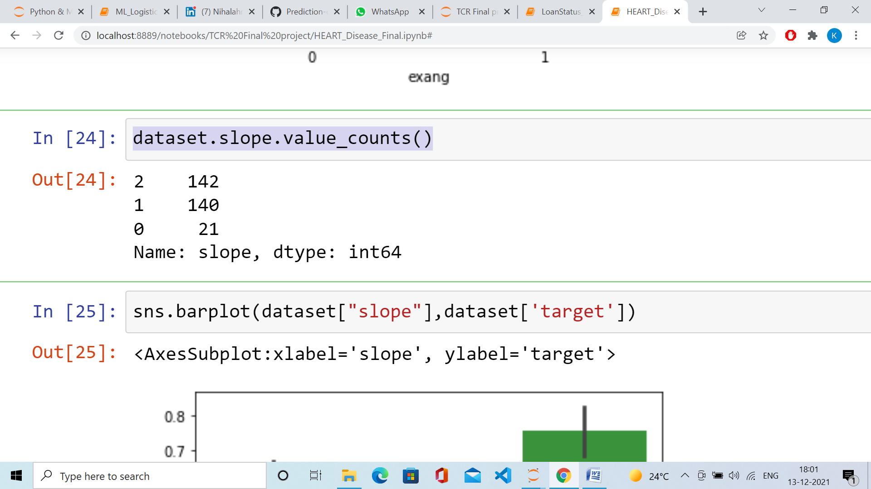

sns.barplot(dataset["slope"],dataset['target'])

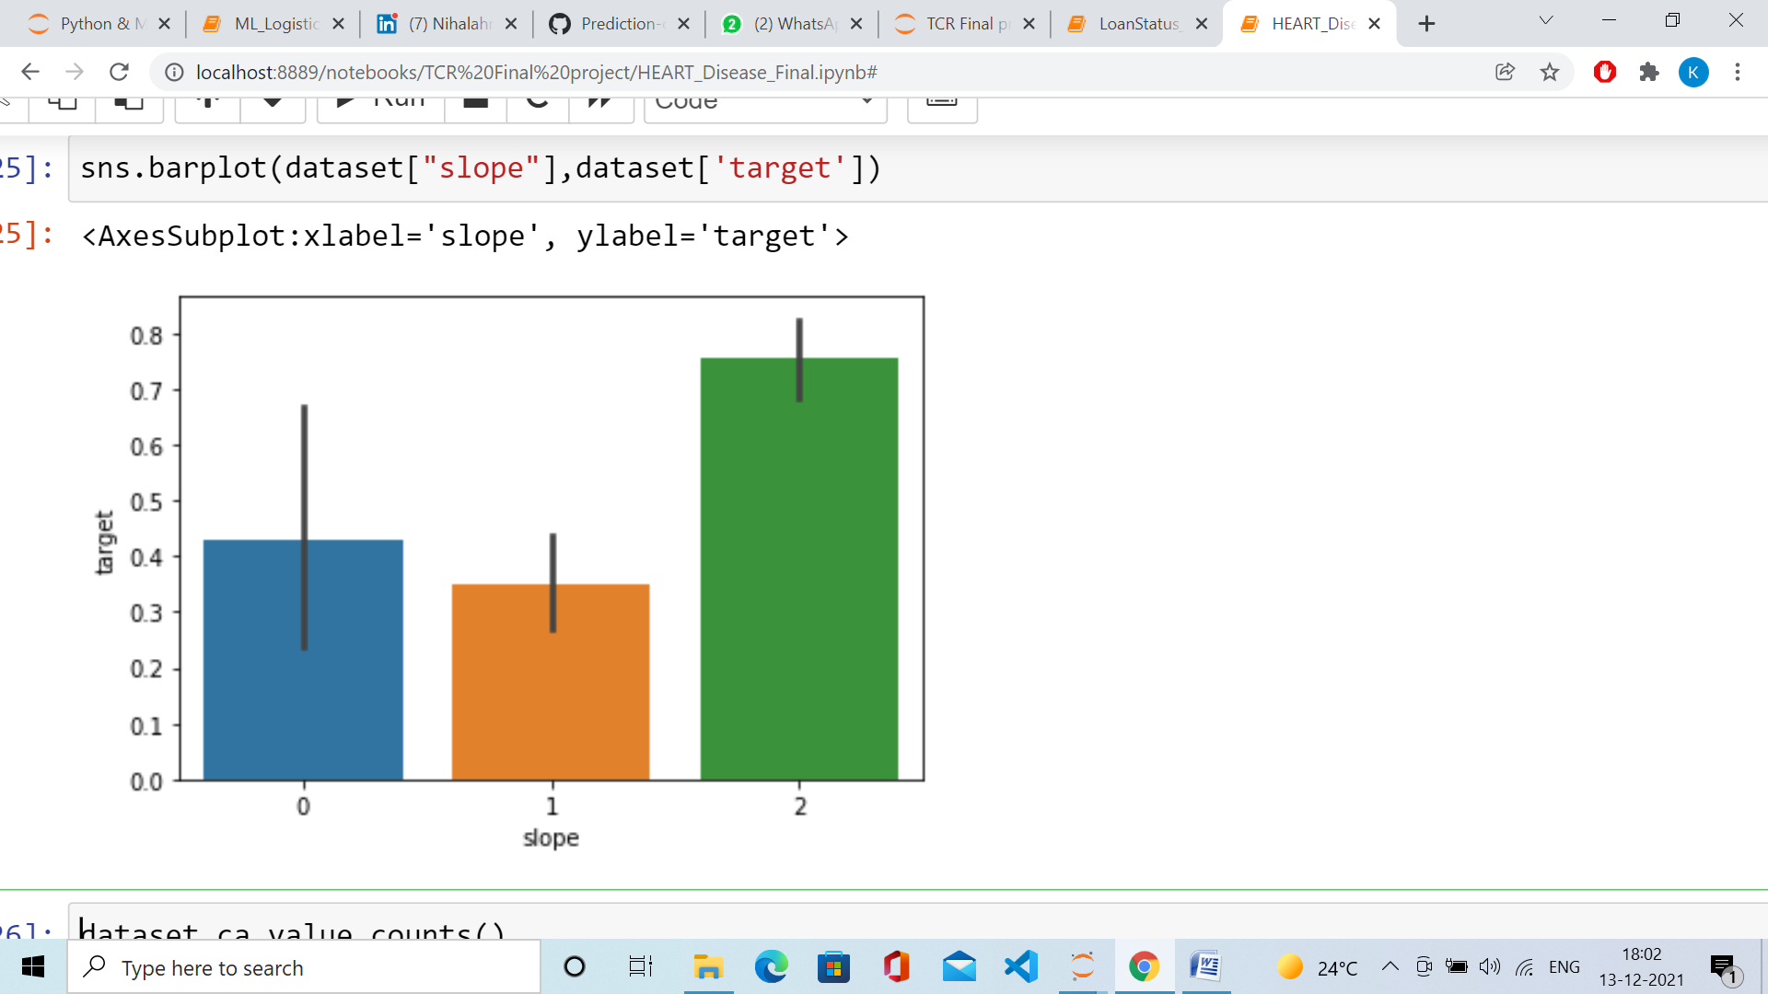

dataset.ca.value_counts()

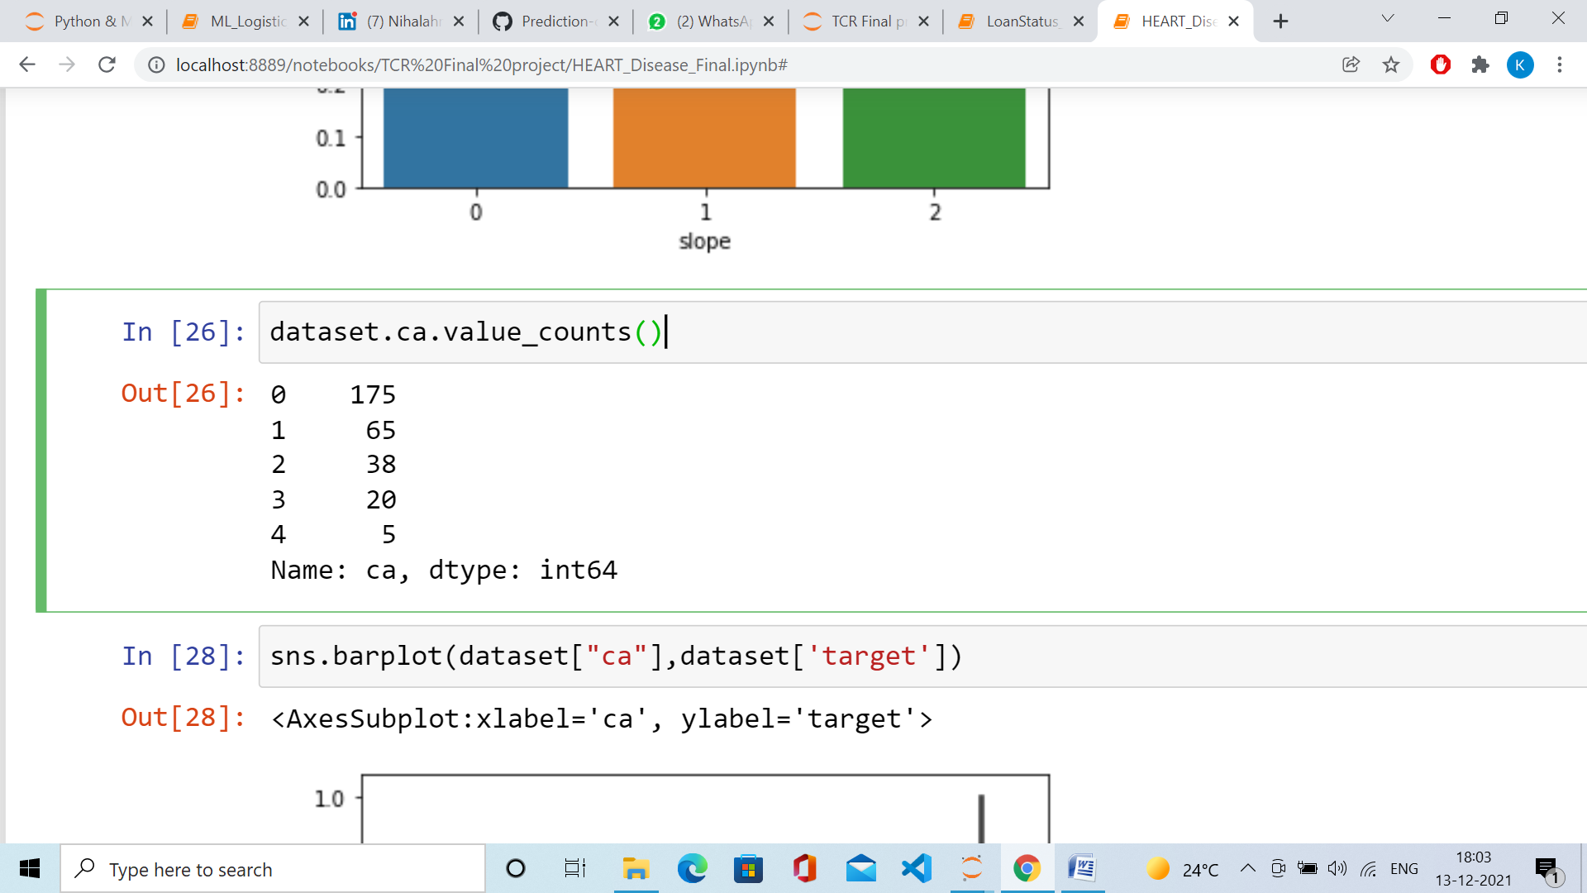

sns.barplot(dataset["ca"],dataset['target'])

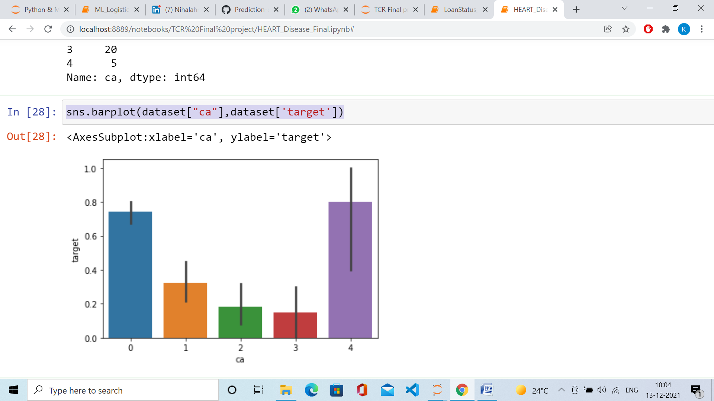

dataset.thal.value_counts()

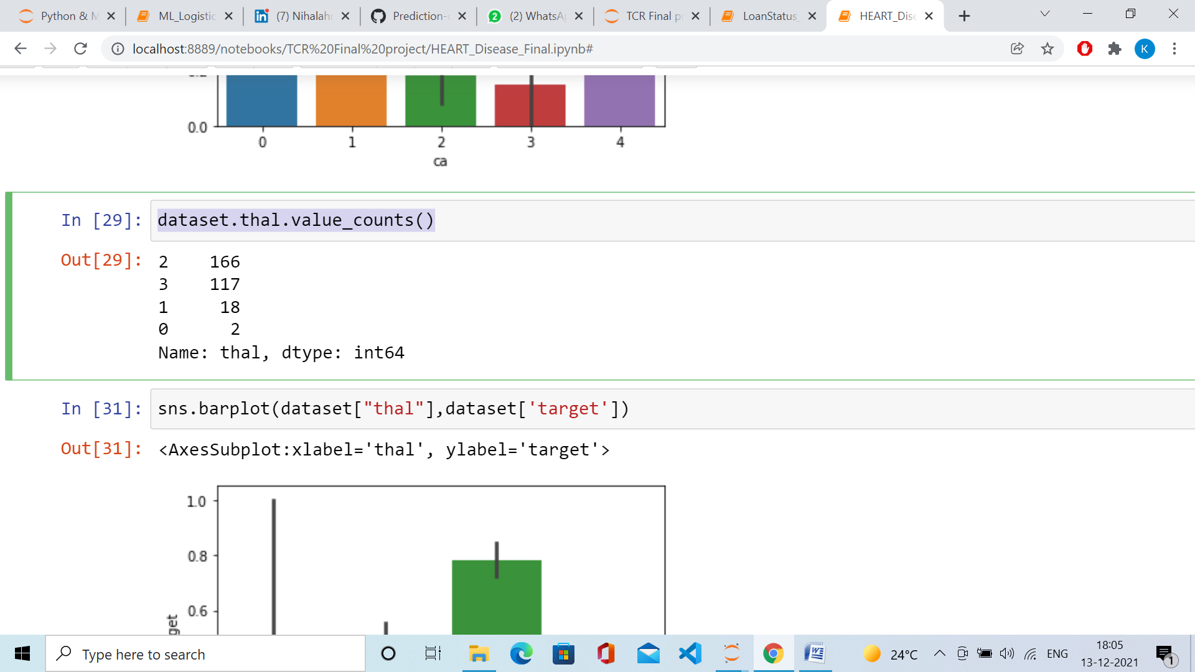

sns.barplot(dataset["thal"],dataset['target'])

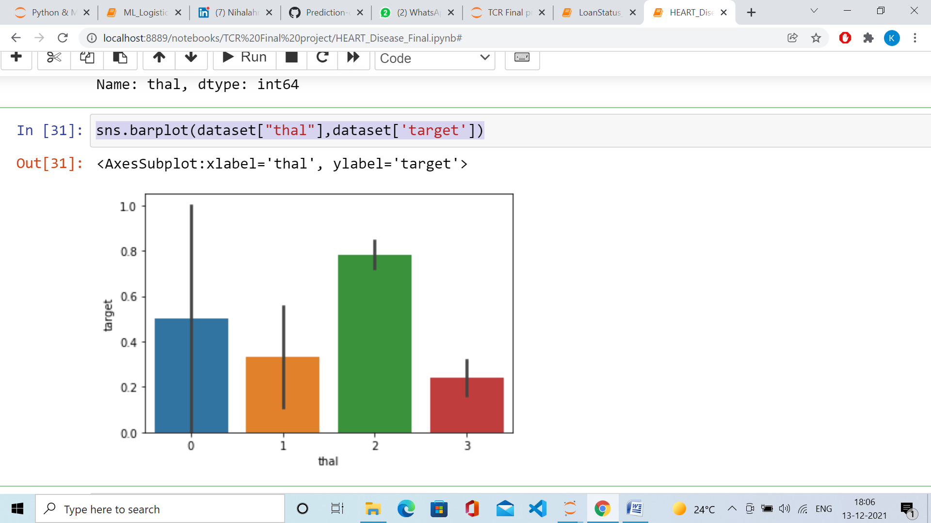

#Overview distribution of each column

dataset.hist(figsize=(16, 20), xlabelsize=8, ylabelsize=8)

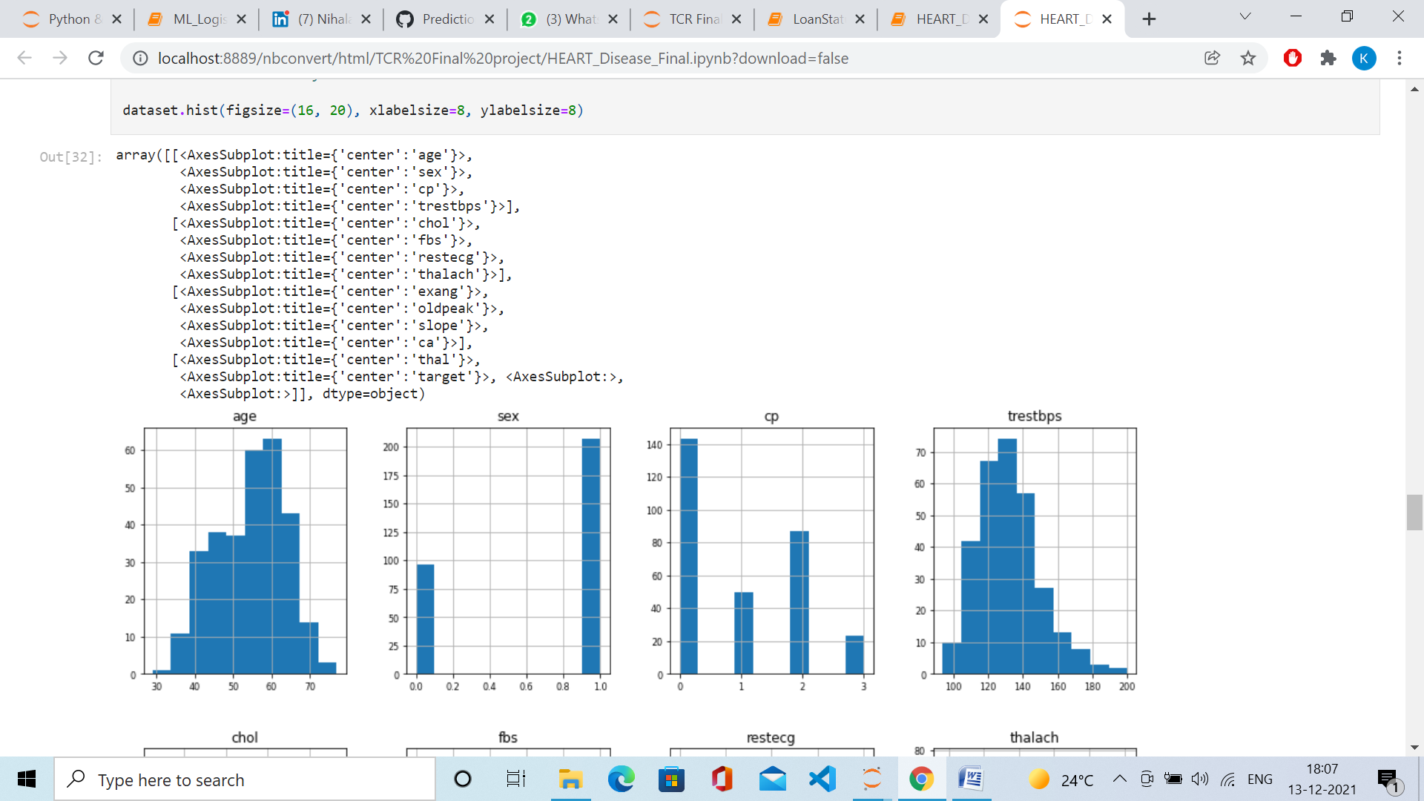

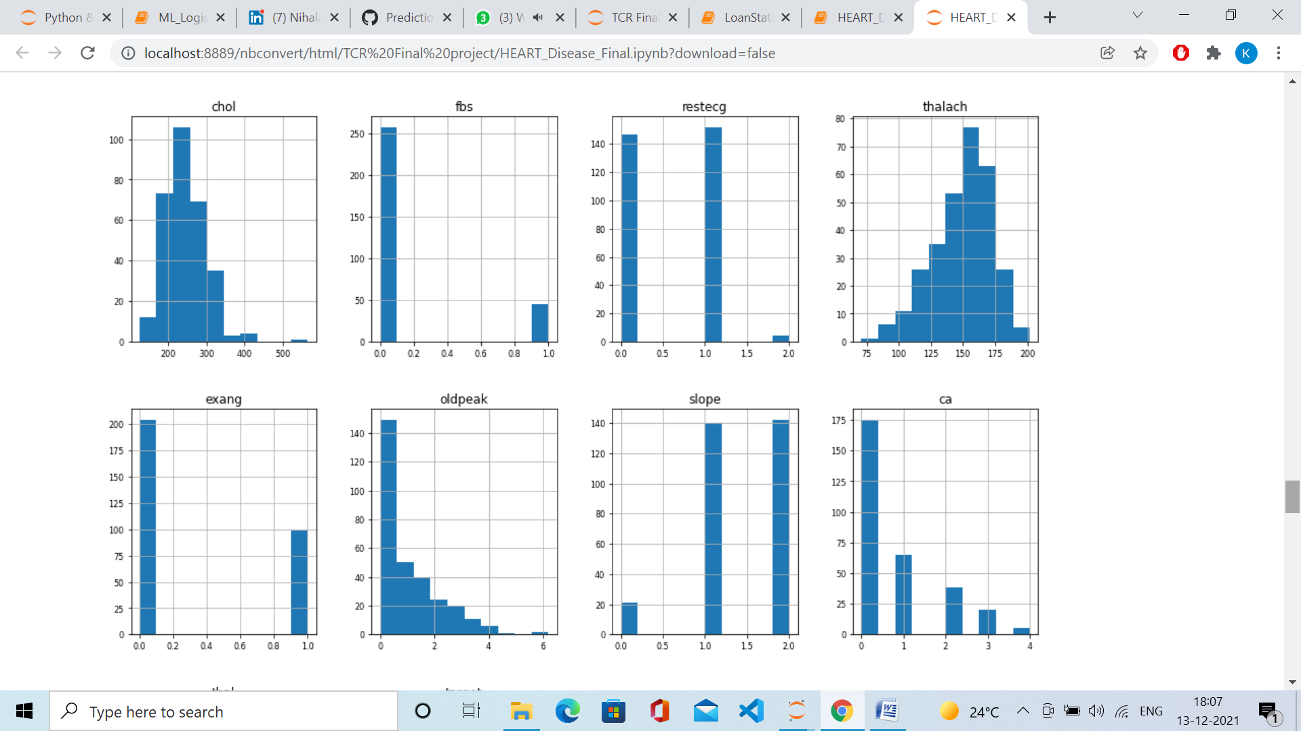

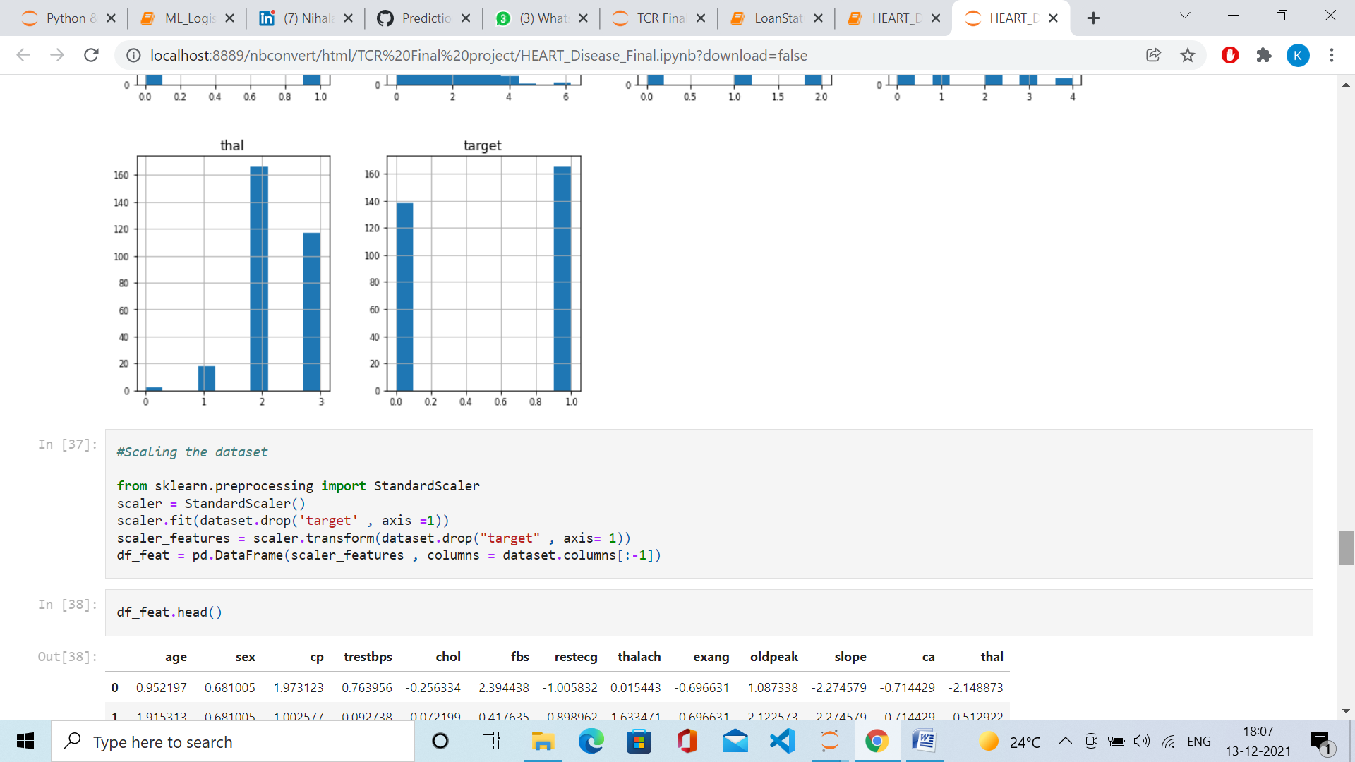

#Scaling the dataset

from sklearn.preprocessing import StandardScaler

scaler = StandardScaler()

scaler.fit(dataset.drop('target' , axis =1))

scaler_features = scaler.transform(dataset.drop("target" , axis= 1))

df_feat = pd.DataFrame(scaler_features , columns = dataset.columns[:-1])

df_feat.head()

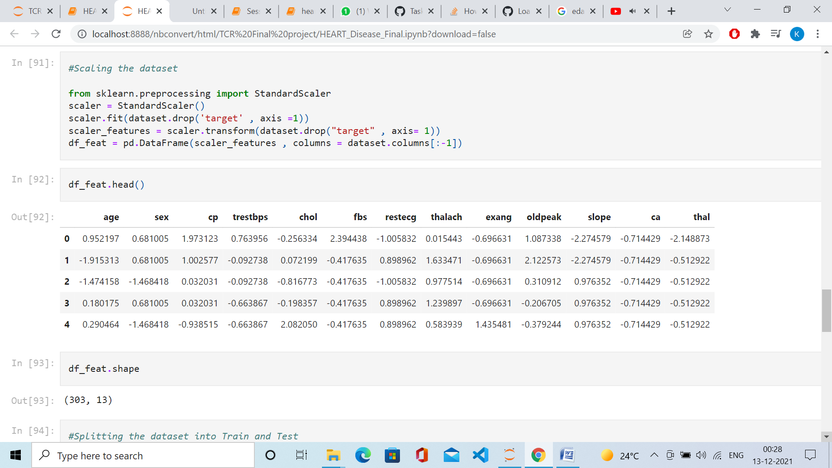

df_feat.shape

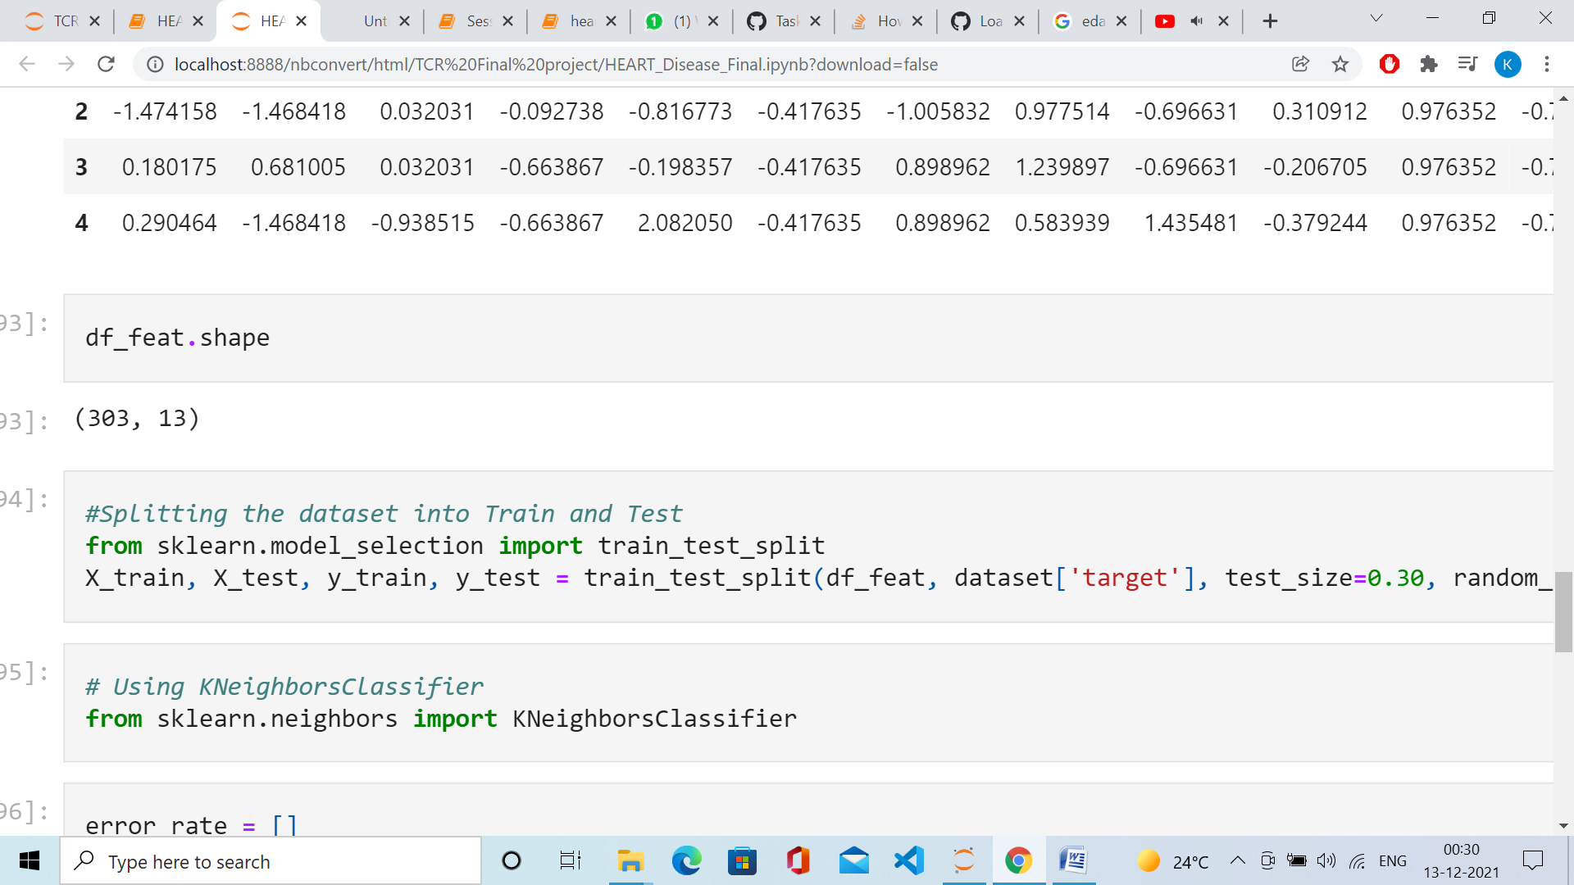

#Splitting the dataset into Train and Test

from sklearn.model_selection import train_test_split

X_train, X_test, y_train, y_test = train_test_split(df_feat, dataset['target'], test_size=0.30, random_state=101)

#Shape of train and test data

print ('Train set:', X_train.shape, y_train.shape)

print ('Test set:', X_test.shape, y_test.shape)

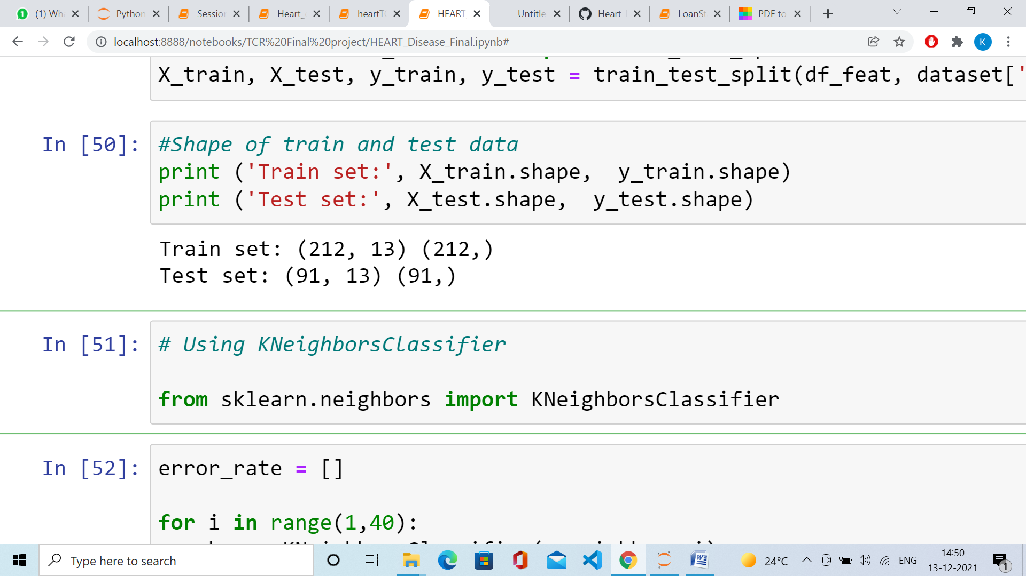

# Using KNeighborsClassifier

from sklearn.neighbors import KNeighborsClassifier

error_rate = []

for i in range(1,40):

knn = KNeighborsClassifier(n_neighbors=i)

knn.fit(X_train,y_train)

pred_i = knn.predict(X_test)

error_rate.append(np.mean(pred_i != y_test))

plt.figure(figsize=(10,6))

plt.plot(range(1,40),error_rate,color='blue', linestyle='dashed', marker='o',

markerfacecolor='red', markersize=10)

plt.title('Error Rate vs. K Value')

plt.xlabel('K')

plt.ylabel('Error Rate')

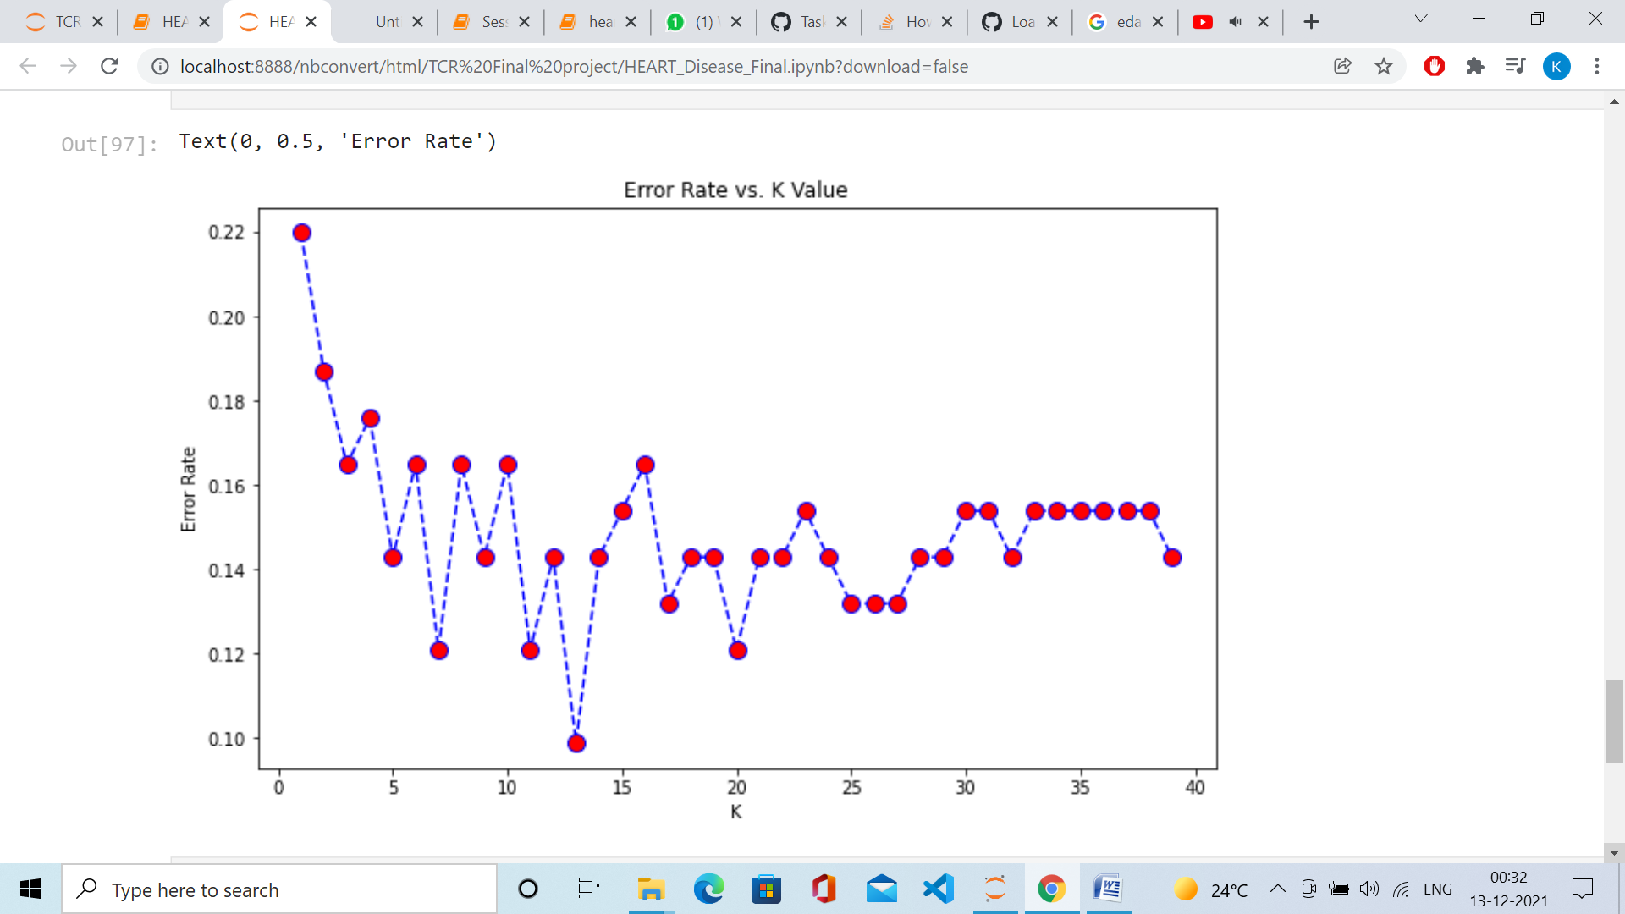

knn = KNeighborsClassifier(n_neighbors = 13)

knn.fit(X_train , y_train)

pred = knn.predict(X_test)

pred.shape

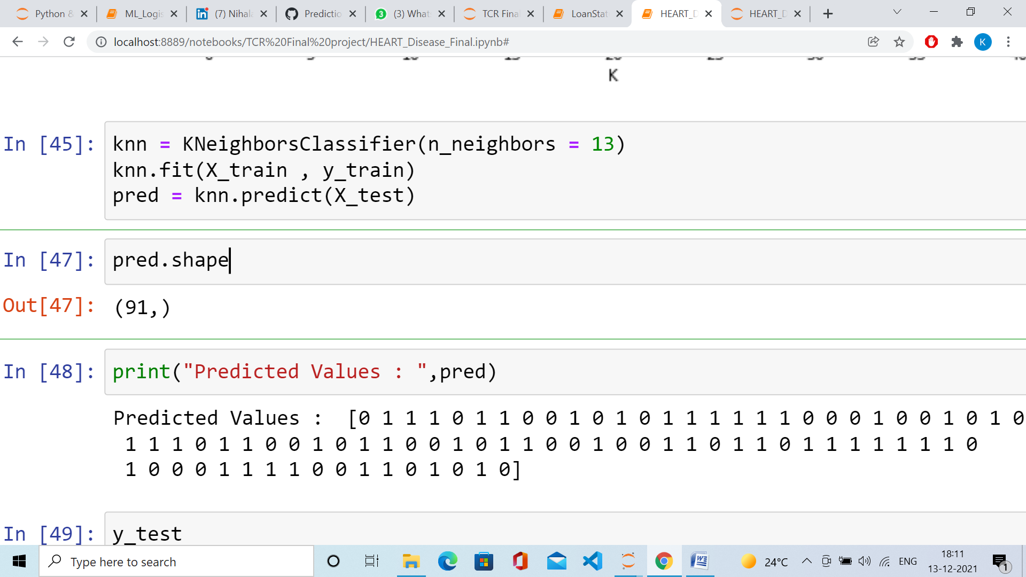

print("Predicted Values : ",pred)

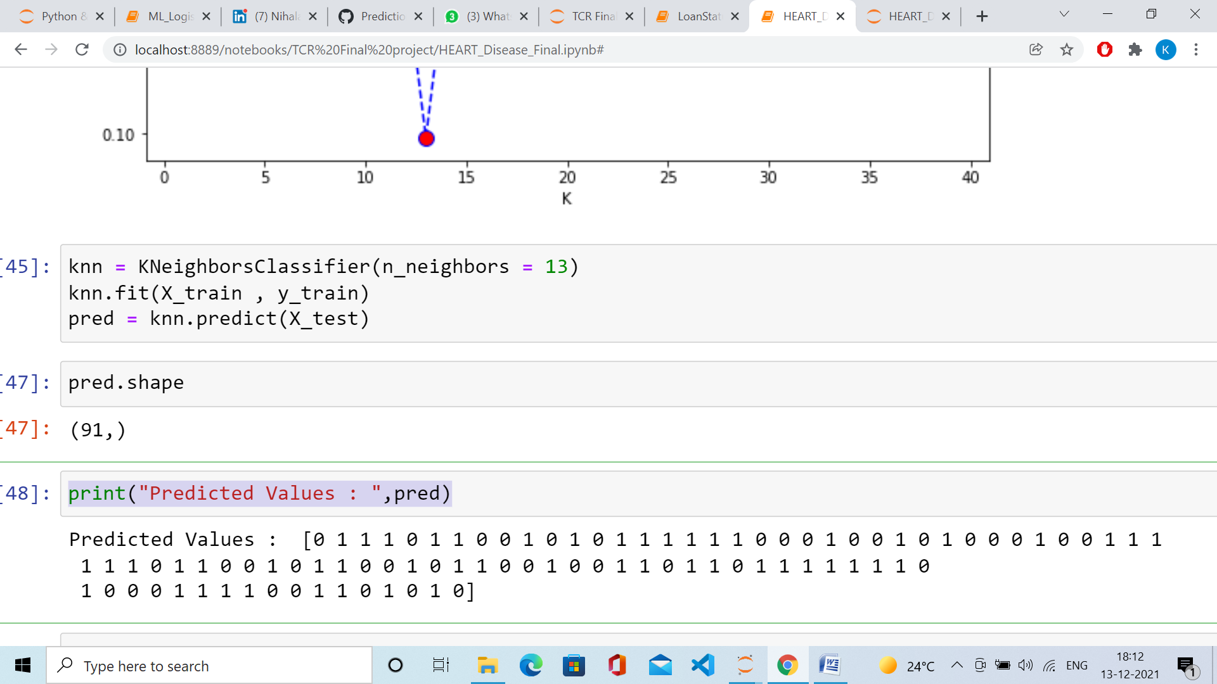

y_test

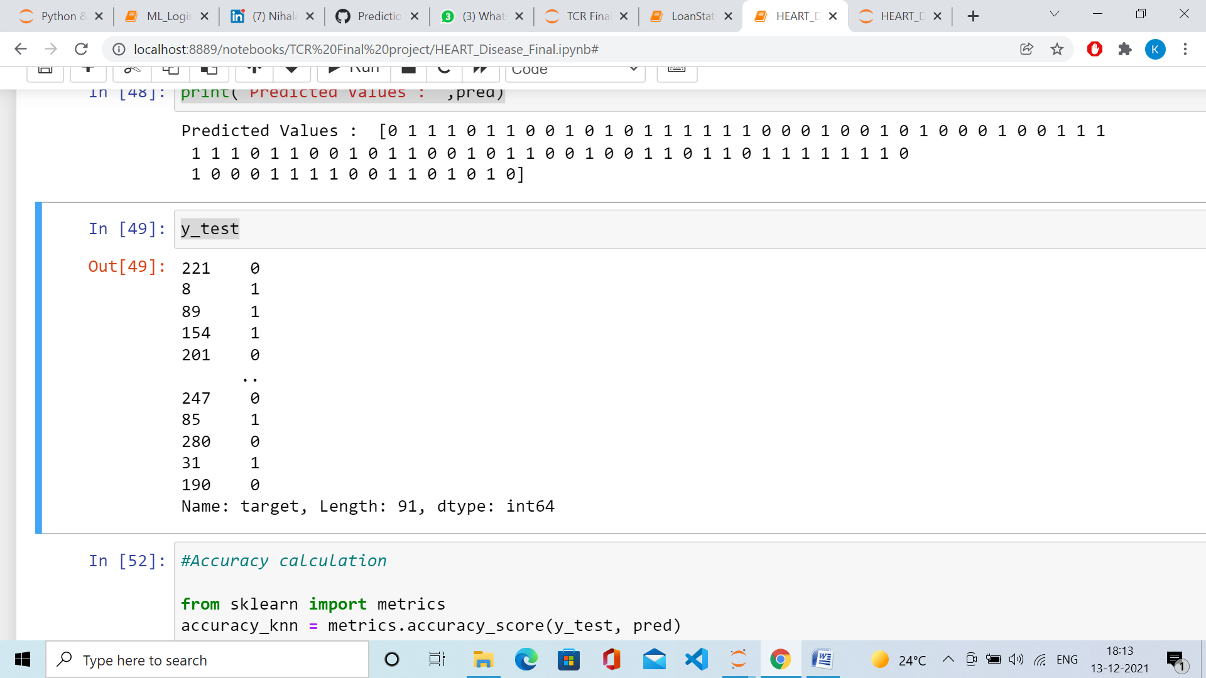

#Accuracy calculation

from sklearn import metrics

accuracy_knn = metrics.accuracy_score(y_test, pred)

print("The accuracy score of KNN is: ",accuracy_knn)

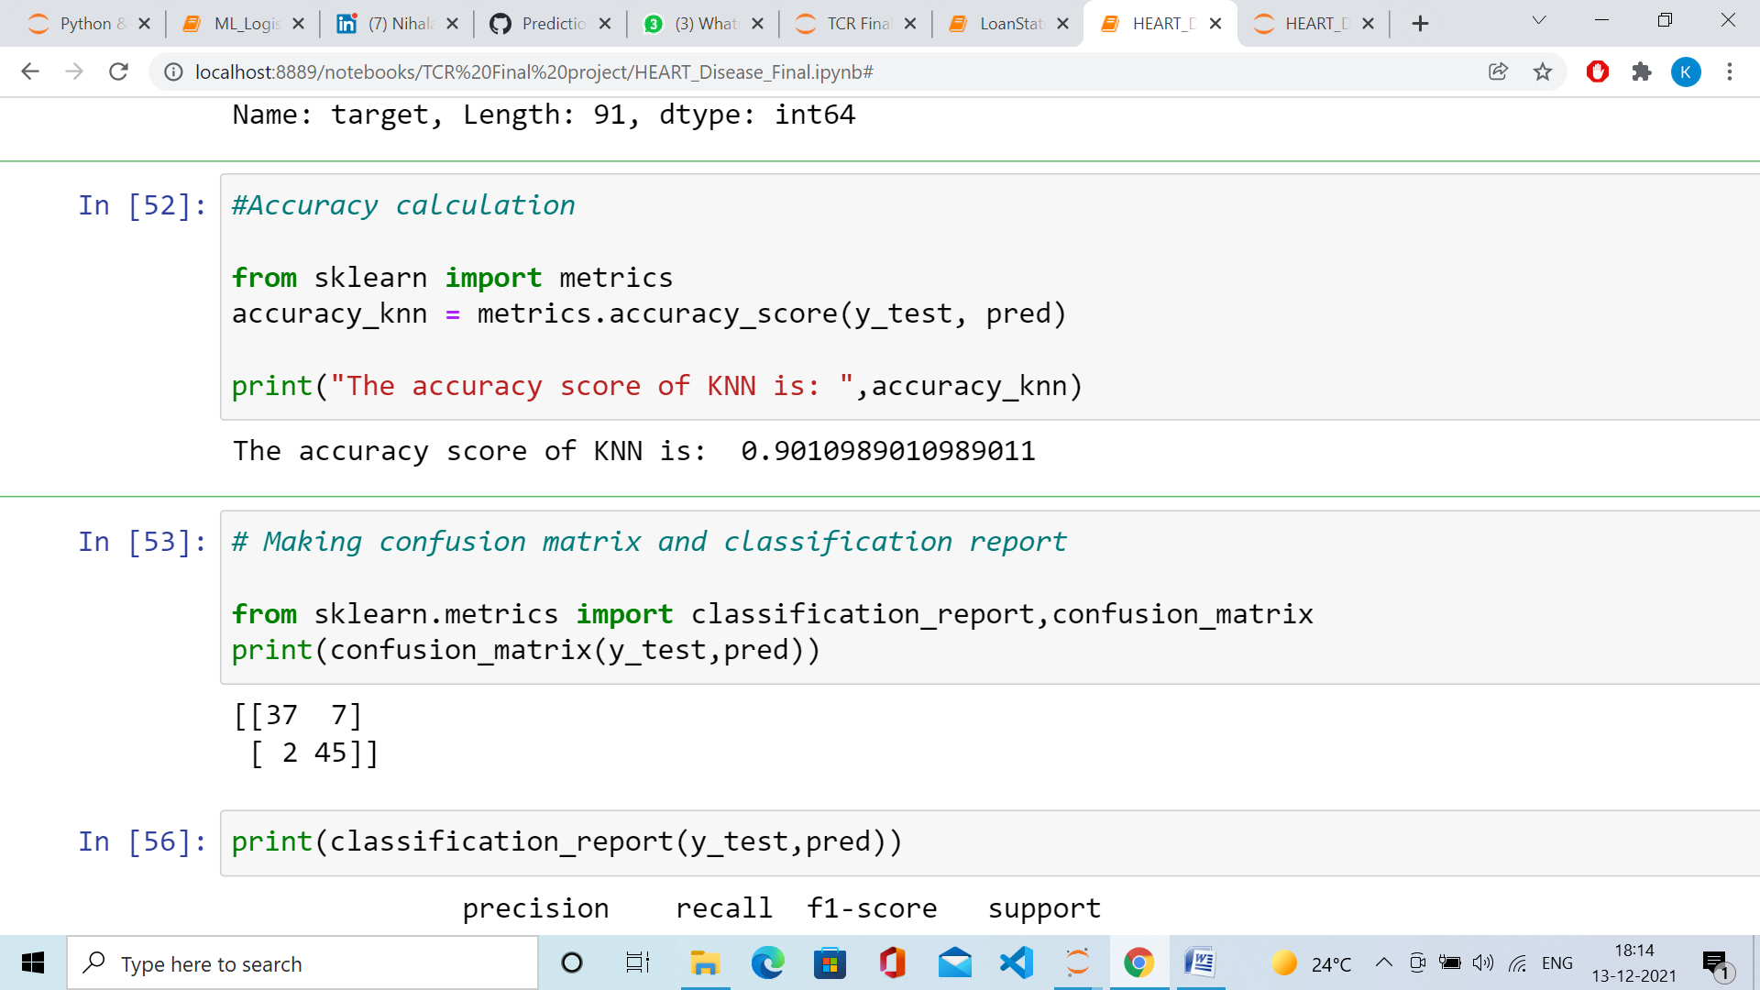

# Making confusion matrix and classification report

from sklearn.metrics import classification_report,confusion_matrix

print(confusion_matrix(y_test,pred))

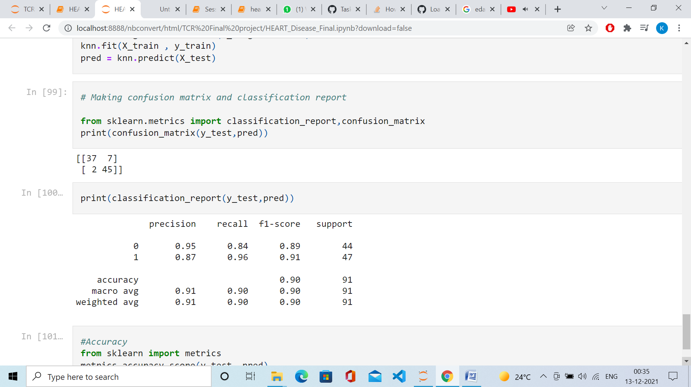

print(classification_report(y_test,pred))

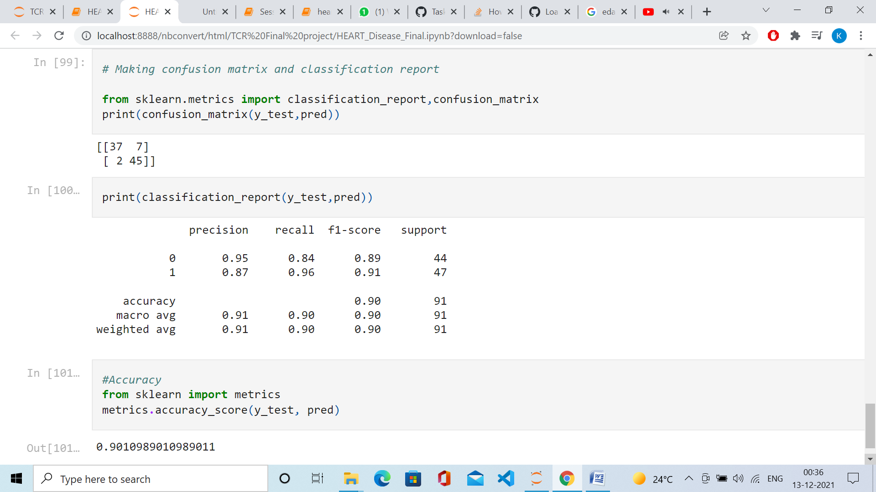

# Conclusion:

# Thus, the accuracy achieved by using KNN is around 90.1 %.